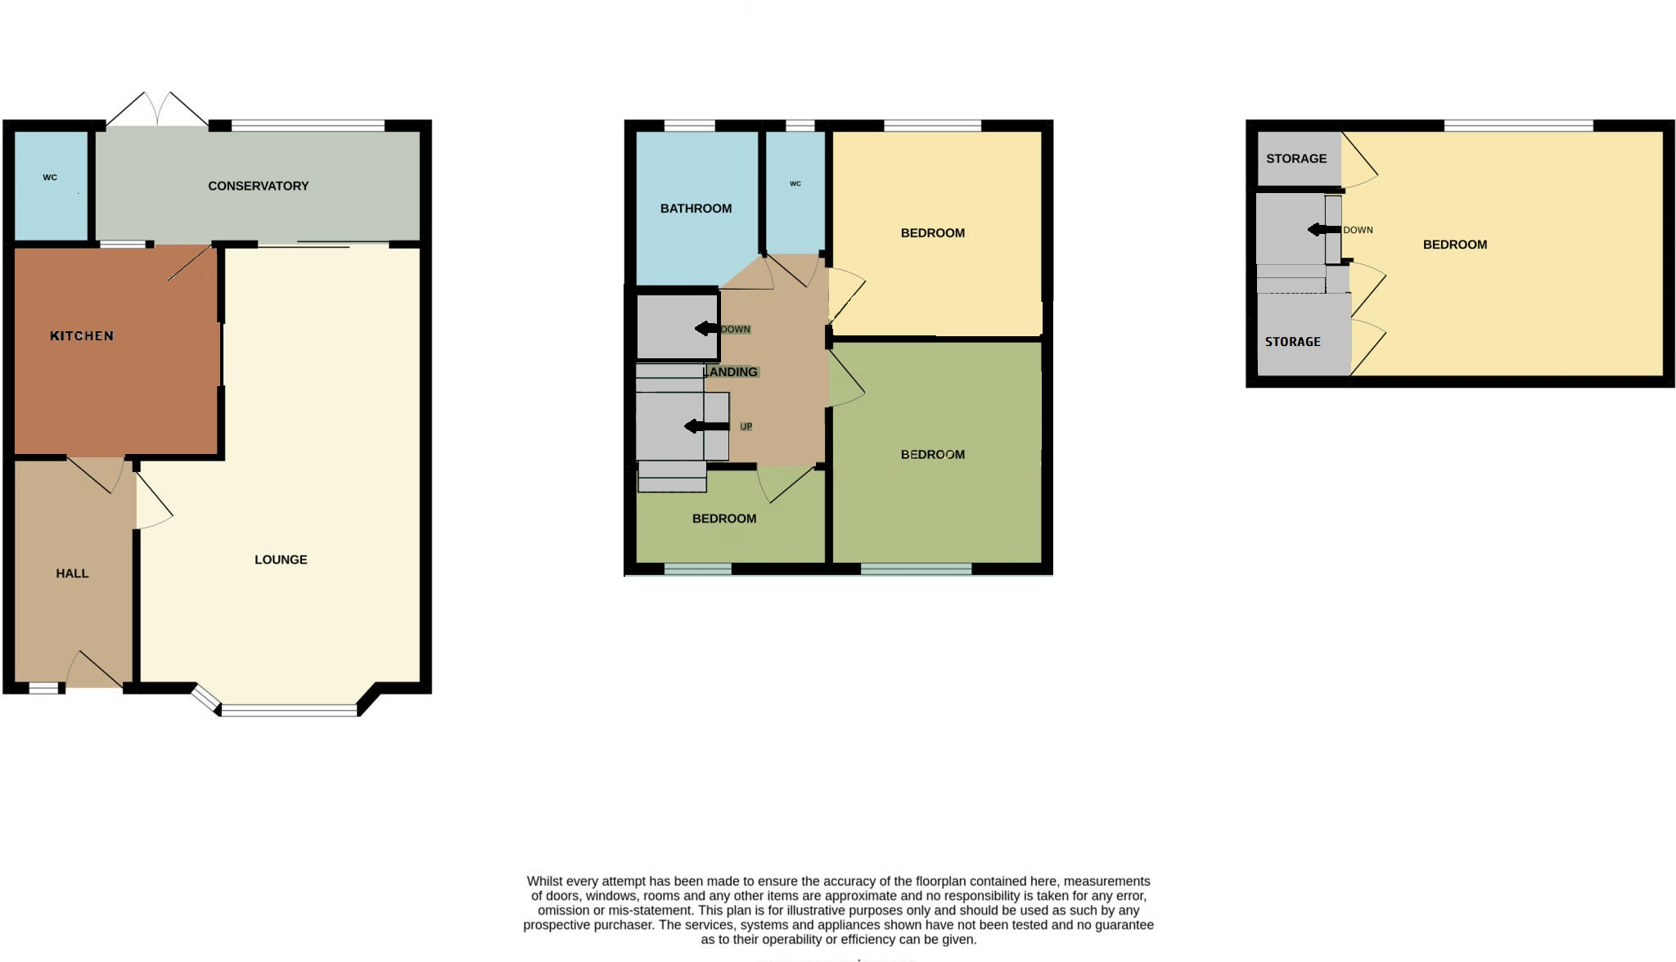

This Floorplan is for illustrative purposes only and should be relied on as such. Whilst every attempt has been made to ensure the accuracy of this floorplan, the measurements of windows, doors, rooms etc. are approximate and no responsibility is accepted for any error. No guarantee is assumed for any appliances, services or systems shown in regards to their operability or efficiency